What is the Internet:

- There are a couple of ways to answer this question:
  - Nuts-and-Bolts Description: Describing the basic hardware and software components that make up the internet
  - A services Description: Describing the internet in terms of a networking infrastructure that provides services to distributed applications

1. Nuts-and-Bolts Description:
  - the basic hardware and software components that make up the internet?
  - The internet consists of end systems (a.k.a hosts because they host or run applications) which are connected to each others through communication links and packet switches
  - There are many types of communication links (coaxical cable, copper wire, optical fiber…) which differ in the rate at which data is being transmitted (transmission rate R)
  - Data being transferred between hosts is actually sent through data packets
  - Packet switches come in many shapes and flavors, but the common ones are routers and link-layer switches
    - Link layer switches are used in access networks
    - Routers are used in the network core
  - The sequence of communication liks and packet switches tranverrsed nu a packet from the source to the destination is known as the route or path
  - End systems access the internet through Internet Service Providers (ISPs) such as local cables or telephone companies. Each ISP is itself a network of packet switches and communication links
  - Internet is all about connecting end systems to each others, so ISPs must also be interconnected (lowertier ISPs are interconnected through national and international upper-tier ISPs, and these upper-tier ISPs are connected directly to each others
  - End systems, packet switches and other components of the internet run protocols that control sending and receiving information within the internet
What is a protocol?
- Human execute protocols all the time. I,e humans define some conventions to send/receive messages between each others so that they can communicate with each others and take actions accordingly
- A network protocol is similar to a human protocol, except that the entities exchanging messages and taking actions are hardware and software components of some device
- For example, hardware-implemented protocols in two physically connected computers control the flow of bits on the wire between the two NICs, congestion-control protocols in end systems control the rate at which packets are transmitted between sender and receiver, protocols in routers determine a packet’s path from the src to dst
- A common internet protocol is the http protocol
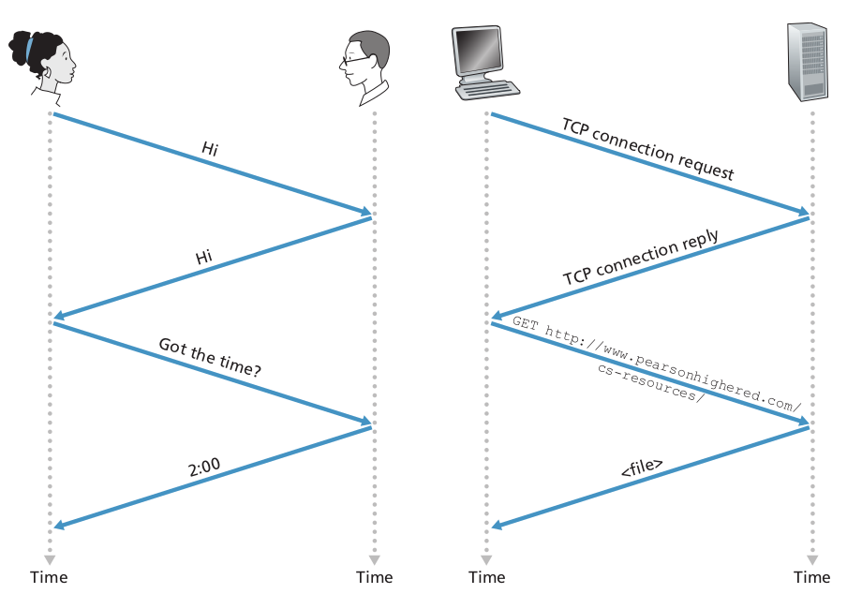
Therefore:
A prtocol defines the format and the order of messages exchanged between two or more communicating entities, as well as the actions taken on the transmission and/or receipt of a message or other event

2. Services Description:
  - We may look at the internet from a different pov, which is that the internet provides services to distributed applications
  - Applications including internet messaging, mapping with real-time road-traffic information, mutlti-gaming applicaions and so on are said to be distributed applications, since they involve multiple end systems that exchange data with each other
  - Internet applications run in end systems or hosts
  - When developing a distributed application, programs running on the different end systems will need to exchange data between each others. The internet is responsible of delivering data to specific destination programs running on different end systems via socket interfaces
  - End systems connected to the internet provide socket interface that specifies how a program running on one end-system asks the internet to deliver data to a specific destination
  - An analogy to this is Alice wants to send a letter to Bob via the postal service.
  - The internet services are described in the application layer

Some terminology:
- Terminals:
  - End systems (also known as hosts because they host or run application programs such as web applications, e-mail client programs, e-mail server programs…) are known as terminals bcs they sit in the edge of the computer network
  - Hosts are further divided into two categories: clients and servers
- Non terminals:
  - Are network devices (components) that contribute to the transmission of packets throughout the internet, they don’t run user applications
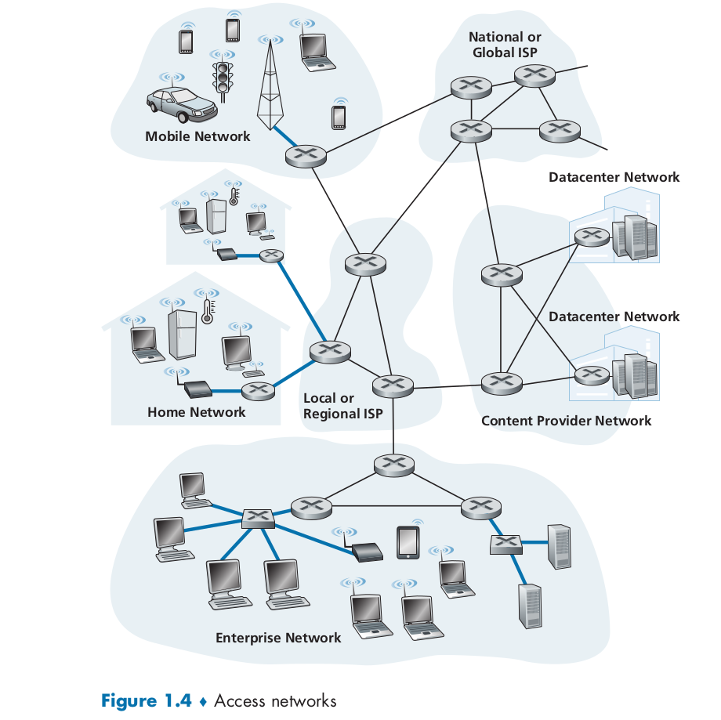
- Access Networks: is the network that physically connects an end system to the first router on the path to any other distant end system

Home Access: DSL, Cable, FTTH, and 5G Fixed Wireless:
- Today, the two most prevalent types of broadband residential access are:
  - Digital subscriber line (DSL): is provided by the same local telephone company (telco) and makes use of the telco’s existing local telephone infrastructure
  - Cable: A residence obtains cable Internet access from the same company that provides its cable television and makes use of the cable television company’s existing cable television infrastructure
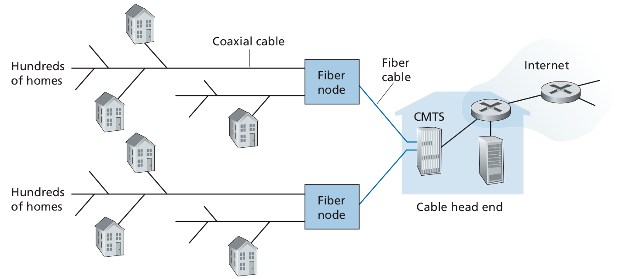
  - Fiber optics connect the cable head end to the neighborhood-level junctions, from which traditional coaxial cable is then used to reach individual houses and apartments
  - Because both fiber and coaxial cable are employed in this system, it is often referred to as hybrid fiber coax (HFC)
  - One important characteristic of cable Internet access is that it is a shared broadcast medium. In particular, every packet sent by the head end travels downstream on every link to every home and every packet sent by a home travels on the upstream channel to the head end
- Although the most widely used residential broadband access today are DSL and broadband, there are new technologies that came into birth:
  - Fiber to the home (FTTH): provides an optical fiber path from the Central Office (CO) to the home
  - 5G Fixed wireless: not only promises high-speed residential access, but will do so without installing costly and failure-prone cabling from the telco’s CO to the home. How does it work?
    - Data is sent wirelessly from the provider’s base station to the modem in the home (using beam forming technology)
    - A wifi wireless router is connected to the modem (possibly bundled together)

Access in the Enterprise (and the Home): Ethernet and WiFi → from the Lab + textbook (16-18)

Physical Media:
- We said that HFC uses a combination of fiber cable and coaxical cable, and that DSL and Ethernet both use copper wire, we will provide an overview of each and other transmission media that are commonly used in the Internet

